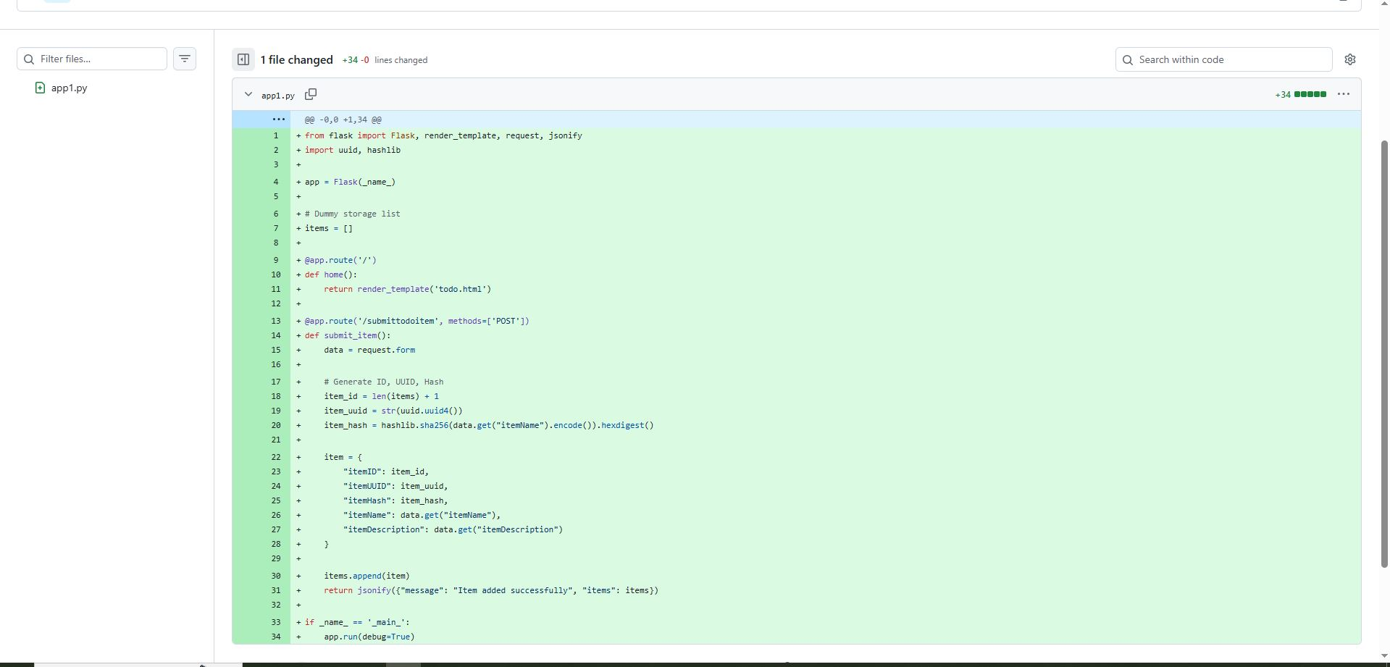

from flask import Flask, render_template, request, jsonify

import uuid, hashlib

app = Flask(_name_)

# Dummy storage list

items = []

@app.route('/')

def home():

return render_template('todo.html')

@app.route('/submittodoitem', methods=['POST'])

def submit_item():

data = request.form

# Generate ID, UUID, Hash

item_id = len(items) + 1

item_uuid = str(uuid.uuid4())

item_hash = hashlib.sha256(data.get("itemName").encode()).hexdigest()

item = {

"itemID": item_id,

"itemUUID": item_uuid,

"itemHash": item_hash,

"itemName": data.get("itemName"),

"itemDescription": data.get("itemDescription")

}

items.append(item)

return jsonify({"message": "Item added successfully", "items": items})

if _name_ == '_main_':

app.run(debug=True)

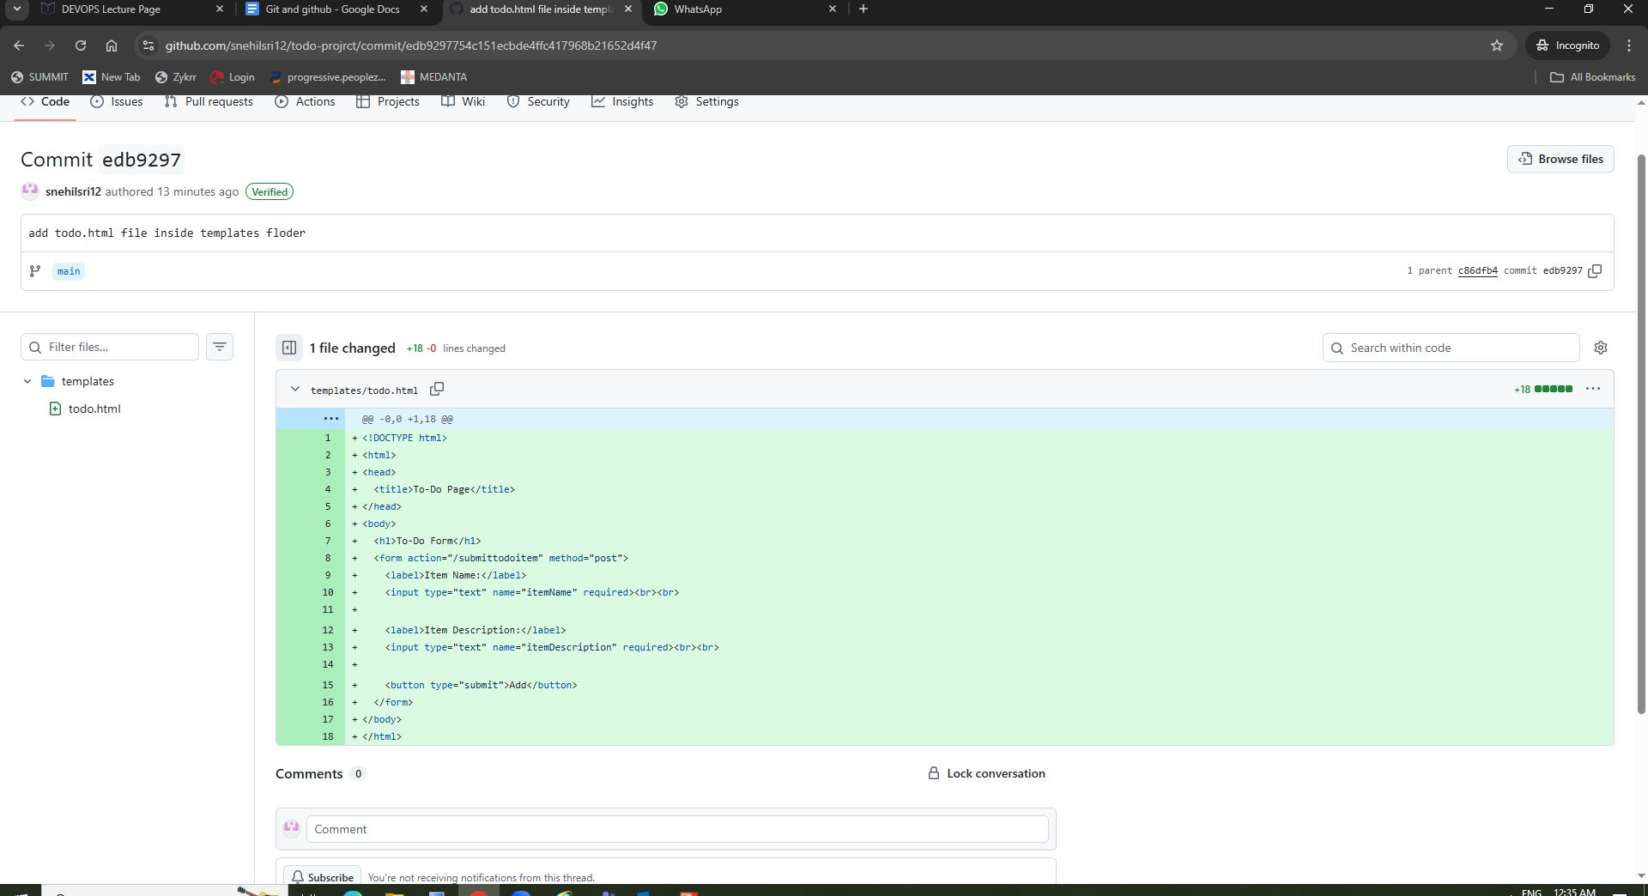

<!DOCTYPE html>

<html>

<head>

<title>To-Do Page</title>

</head>

<body>

<h1>To-Do Form</h1>

<form action="/submittodoitem" method="post">

<label>Item Name:</label>

<input type="text" name="itemName" required><br><br>

<label>Item Description:</label>

<input type="text" name="itemDescription" required><br><br>

<button type="submit">Add</button>

</form>

</body>

</html>

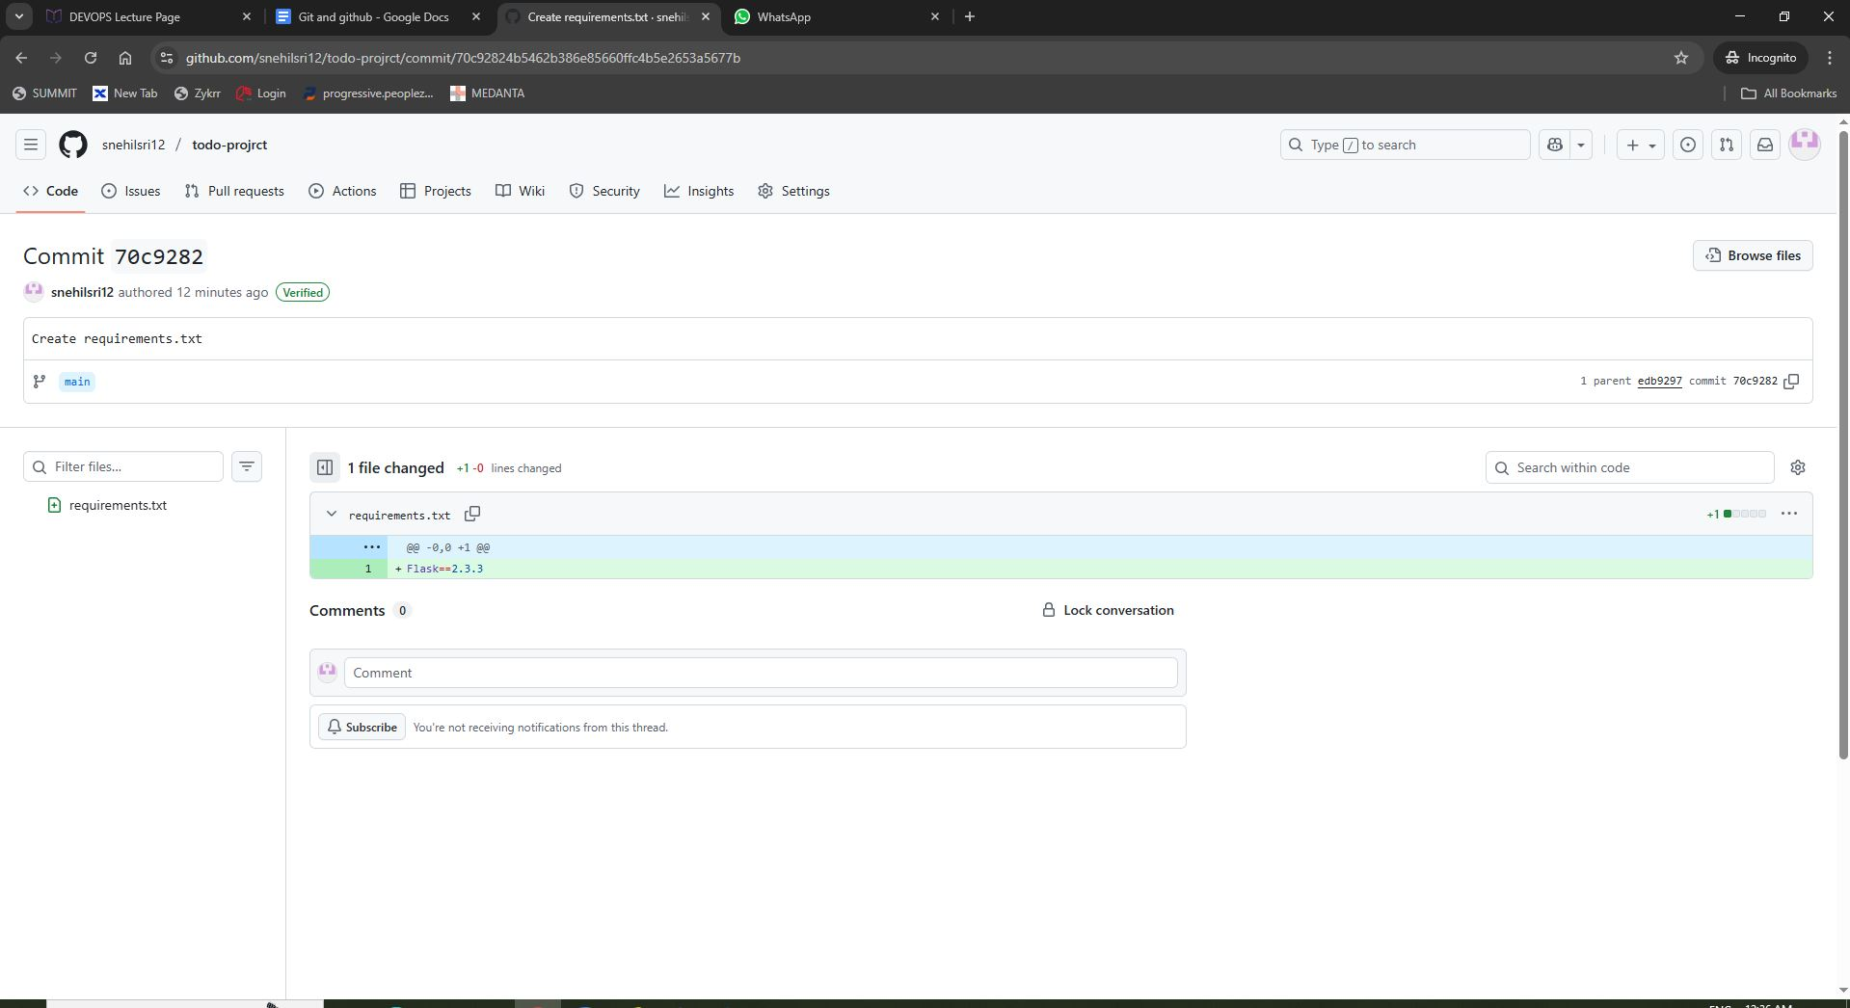

Flask==2.3.3

